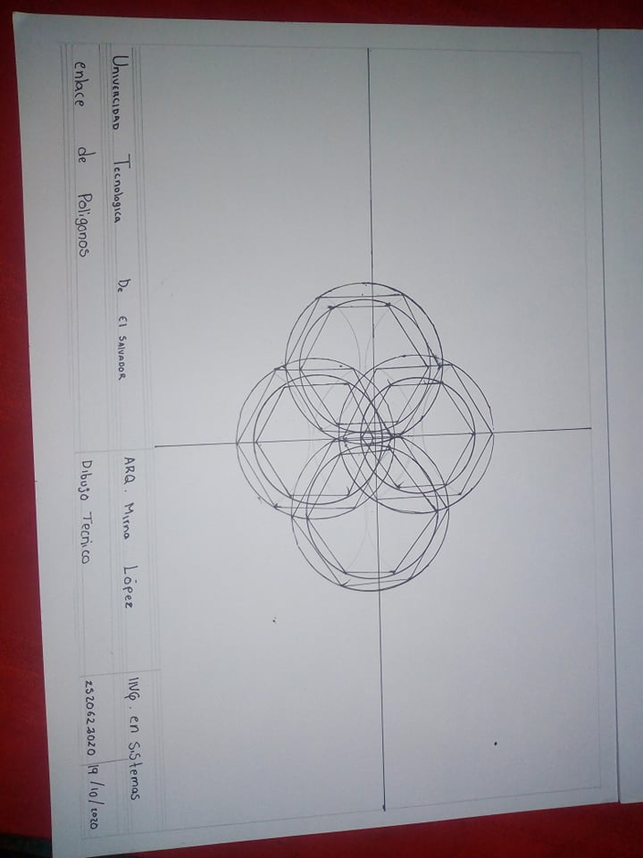

Krissia Magali Dueñas Molina 2520622020